The Risk Assessment below is an outline of risks that will need to be considered at your event. Please delete any lines that are not applicable to the event that you are running. Please note that this is only a suggestion of risks to be considered, and you will need to carry out your own in-depth risk assessment before the event, inserting any additional risks to the template below.

The British Society of Soil Science does not take any responsibility for your event, and a final risk assessment will need to be approved by the event venue.

Responsible Person and contact number |  | Deputy Responsible Person and contact number
Event Name |  | Number of Delegates expected
Meeting Date |  | Times
Location |  | Type of Audience i.e. professionals, public

Operational/ Events | Significant Hazards | Who is Affected? | Existing Controls and Limitations | Existing Risk Rating  (Likelihood x significance + significance) |  |  | Proposed Controls | Existing Risk Rating  (Likelihood x significance + significance)
 |  |  |  | L | S | Risk | Proposed Controls | L | S | Risk
Classroom based learning | Slip hazards | Teachers, Activity Host(s) | - Ensure any spills are cleared away quickly and that all areas remain clean and tidy | 3 | 3 | 12 | - On-going inspection by teachers or Activity Host  - Warn attendees of hazard | 1 | 3 | 6
Field based learning (including soil pit digging and soil augering) | Trip hazards | Activity Host(s), attendees,  General public | - Ensure Activity Host clears away any equipment quickly and that all areas remain clean and tidy  - Ensure any large open pits and hazards are cordoned off with hazard tape | 3 | 3 | 12 | - On-going inspection by Activity Host | 1 | 3 | 6
 | Lifting and carrying of equipment | Activity Host(s), attendees | Ensure Activity Host is aware of basic manual handling principles | 3 | 4 | 16 | - Use trolleys where possible for moving heavy items | 1 | 3 | 6
 | Infection and illness including E-coli 0157 | Activity Host(s), attendees | - Follow basic hygiene rules at all times.  - Avoid transmission of infection from hand to mouth.  - Ensure hand washing facilities, wipes and signage are readily available and visible.  - Wash hands thoroughly after handling soil.  - Ensure appropriate supervision for hands on activities. | 1 | 4 | 8 | - Briefing of any volunteers | 1 | 3 | 6
 | Lack of Group Control resulting in crush injury or accidental damage | Activity Host(s), attendees | - Close supervision of attendees by Activity Host  - The Activity Host and volunteers are well briefed on the hazards and controls | 1 | 2 | 4 | - Briefing of all volunteers | 1 | 2 | 4
 | Digging through buried Services | Activity Host(s), attendees | - Refer to land owner for historical information on site, refer to maps to ensure that potential hazards associated with site are clearly identified  - Danger to the public from poorly back-filled soil pits | 2 | 4 | 12 | - Control depth of excavation/augering to less than 1 m  - All pits to be fully backfilled and the turf or surface layer placed back on the packed down subsoil and stamped down | 1 | 3 | 6
 | Exposure/ wet weather | Activity Host(s), attendees | - Ensure Activity Host and volunteers have appropriate clothing for outside working conditions (waterproofs, warm clothing, sunscreen etc.) | 1 | 2 | 4 | - Instructions about appropriate field clothing and footwear in event information | 1 | 2 | 4
 | Use of soil augers causing impact injury/ cut or back injury | Activity Host(s), attendees | - Ensure adequate training prior to use of augers  - Stout boots must be worn | 3 | 4 | 16 | - Ensure volunteers and attendees are well supervised at all times | 1 | 3 | 6
Travel between sites by road assuming personal cars will be used | Road accident | Activity Host(s) and volunteers | - Give clear route instructions | 2 | 4 | 8 | - Provide transport (minibus or coach) if required | 1 | 3 | 6
Event Stand | Falling poster board | Activity Host(s)  Volunteers  Public | - Securely fasten board with tent pegs, remove if wind increases | 2 | 2 | 6 | - On-going check of weather conditions | 2 | 2 | 6
Event Stand | Electricity amp | Activity Host(s)  Volunteers  Public | - Location of electricity amp to be determined by Activity Host on arrival. | 2 | 4 | 10 | - Assess location and ensure access is only for Activity Host and volunteers. To be kept out of the way of the public and under shelter. | 1 | 4 | 5
Event Stand | Lone working | Activity Host(s)  Volunteers | - At least 2 volunteers to be on site for duration of event hours. Event is attended by other exhibitors and the public. | 1 | 2 | 3 | - Existing controls are sufficient | 1 | 2 | 3

Emergency Planning Arrangements Relating to the Event

First Aid Provision and emergency contacts | Basic first aid kit with the Responsible Person
First Aid Provision and emergency contacts | Where the event will include an outdoor element, the Responsible Person should have undertaken relevant first aid training in advance
First Aid Provision and emergency contacts | Contacts and procedures to be provided by name of venue in advance of the event and attached to this risk assessment. Procedures should include/ Event Host should focus on:  - keeping people away from immediate harm  - summoning emergency services (i.e. how to dial out on venue phones)  - how to handle casualties  - crowd management and evacuation procedures (including for disabled participants)  - how to deal with those displaced but not injured  - who will liaise with emergency services  - traffic management including directing emergency vehicles  - protecting property after preserving life.
Fire | Emergency procedures in the event of a fire to be provided by name of venue in advance of this event and attached to this risk assessment. Procedures should include/ Event Host should focus on:  - keeping people away from immediate harm  - summoning emergency services (i.e. how to dial out on venue phones)  - onsite response (i.e. fire extinguishers. Neither delegates nor Responsible Person to attempt to tackle the fire unless they have had training on the equipment to be used)  - how to handle casualties  - crowd management and evacuation procedures (including for disabled participants)  - how to deal with those displaced but not injured  - who will liaise with emergency services  - traffic management including directing emergency vehicles  - protecting property after preserving life.
Weather (outdoor event) | Basic first aid kit with the Responsible Person
Weather (outdoor event) | Where the event will include an outdoor element, the Responsible Person should visit the location in advance and establish emergency procedures for adverse weather including sudden heavy rain, flooding and wind.
Unavailability of key staff | In the case that the Responsible Person is unable to attend the event, the Deputy Responsible person will take responsibility for the delivery of the event.
Unavailability of key staff | If the Deputy Responsible Person is also unable to attend the event, the event will be cancelled.
Unavailability of key staff | If the event is cancelled, prior to the event taking place, all delegates will be notified in advance by email and/or text and confirmation will be requested to ensure they do not make an unnecessary journey.
Speaker/ Invited Guest Cancellation | If the speaker cancels prior to the event taking place, all delegates will be notified in advance by email and/or text.
Speaker/ Invited Guest Cancellation | Where the speaker/ guest cancels and this effects the running order of the event, the Responsible Person should review the programme and make changes where possible.
Speaker/ Invited Guest Cancellation | It is unlikely that the cancellation of a speaker will have significant impact on a delegate’s enjoyment of the event, or result in any on site disturbances. If it does, the Responsible Person should follow the guidelines for first aid provision and emergency contacts
Other

 | Name | Signature | Date
Risk Assessment Completed by:
Risk Assessment Checked by:
Authorising Person:

Risk Assessment Matrix and indicator key
SIGNIFICANCE (CONSEQUENCE) | LIKELIHOOD
1. Insignificant (delay only) | 1. Remote (Improbable / very unlikely)
2. Minor (minor injury / damage / interruption) | 2. Unlikely
3. Moderate (lost time injury, illness, damage, lost business) | 3. Possible (Even chance / may happen)
4. Major (major injury / damage, lost time business interruption, disablement) | 4. Probably (likely)
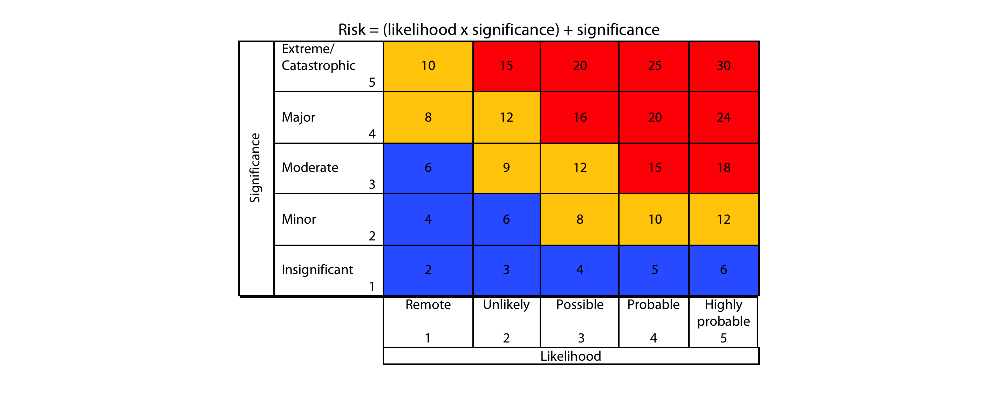  5. Extreme/ Catastrophic (fatality / Business closure) | 5. Highly Probable (Almost certain / imminent)

